**Step by step guide** on how to get the XPath for an element and validate it using **Chrome Developer Tools**:

**📍 Step 1: Open Chrome Developer Tools**

1. Open Google Chrome.
2. Go to the web page where your element exists.
3. Right-click on the element you want to find the XPath for.
4. Click **"Inspect"** — this will open the **Elements** tab in Developer Tools.

**📍 Step 2: Copy XPath of the Element**

1. In the **Elements** tab, the HTML code for the selected element will be highlighted.
2. Right-click on the highlighted element in the Elements tab.
3. Hover over **Copy**.
4. Select **Copy XPath**.

**📍 Step 3: Validate the XPath using Chrome Developer Tools**

1. In the **Elements** tab (still open), press **Ctrl + F** (Windows/Linux) or **Cmd + F** (Mac). This will open the **Search bar** inside the Elements panel.
2. Paste the copied XPath into the search bar.
3. If the XPath is correct, it will highlight the element in the DOM, and you will see a 1 of 1 result count next to the search bar.
4. If the XPath is invalid or does not match any element, the search will return **0 results**.  
     
   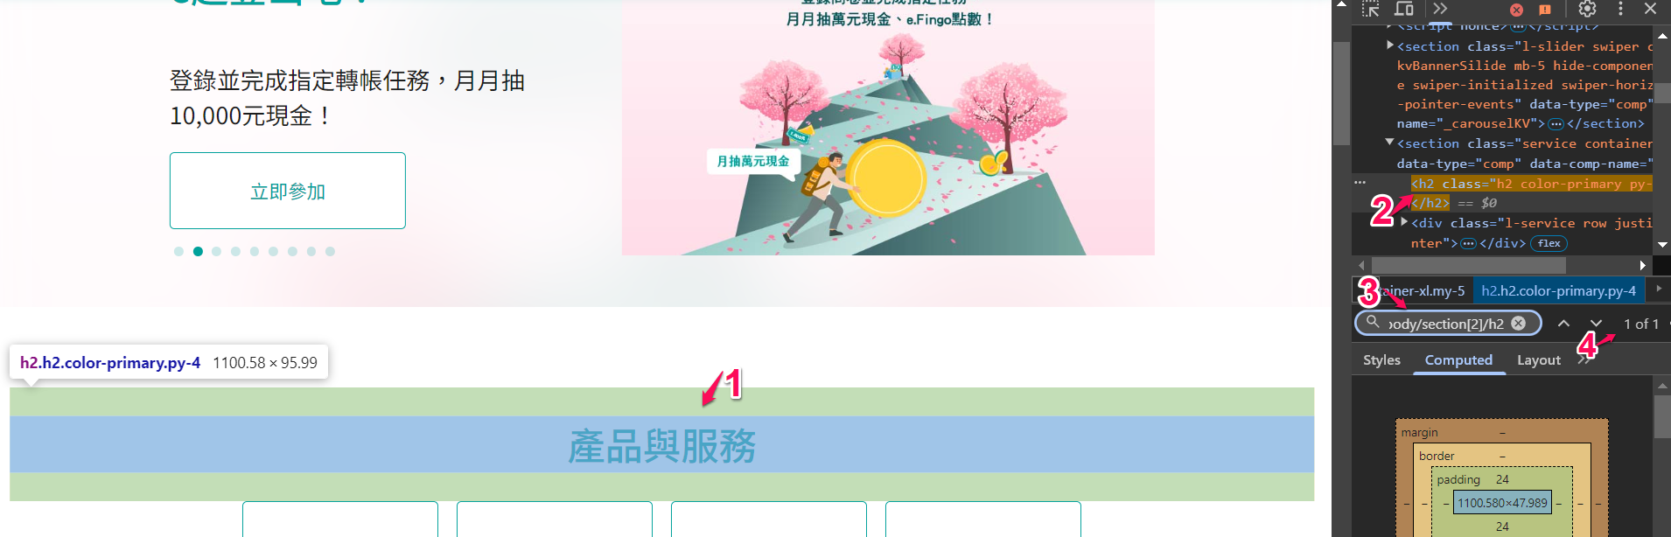

**📍 Step 4 (Optional): Manually Modify/Shorten XPath (if needed)**

* Sometimes, automatically generated XPath is too long or contains unnecessary indices.
* You can manually shorten it to something more **robust**, like using:
* //button[@id='submit'] // Short and reliable
* Validate your manually edited XPath using the **same Ctrl+F or Cmd+F search bar**.

**📍 Pro Tip: Use Copy Selector if CSS Selector is needed instead of XPath**

* Right-click on the element → Copy → **Copy Selector** (for CSS Selector).
* CSS Selectors are often shorter and **more readable** than XPath, so they are preferred for testing in tools like Selenium.